# Running an application for testing on Repl.it

## Fork a Repl on Repl.it

**Step 1:** Navigate to[**https://replit.com/**](https://replit.com/)**.** You need to register, if you don’t have an account. It's really easy, so we won’t explain the registration process.

**Step 2:** Log in and navigate to **the app that you want to fork.**

<https://replit.com/@SoftUniQA/TaskBoardV01?v=1>

<https://replit.com/@SoftUniQA/TaskBoardJSV02?v=1>

**Step 3:** Hit the "Fork & Run" button on the upper right corner.

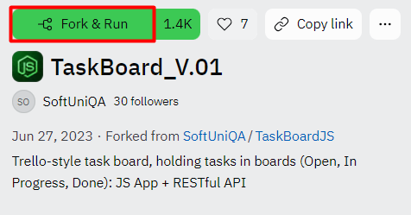

**Step 4:** A pop-up window will appear. Give your app a name, set privacy to public and click "Fork Repl".

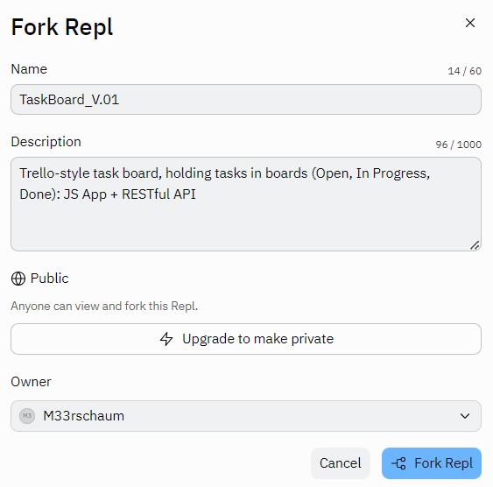

**Step 5:** Give it some time to load and when a green button appears in the top middle of the screen click it. This should open the application's webview.



**Step 6:** If you want to open the app on new tab, click on the small  button on the top right corner.

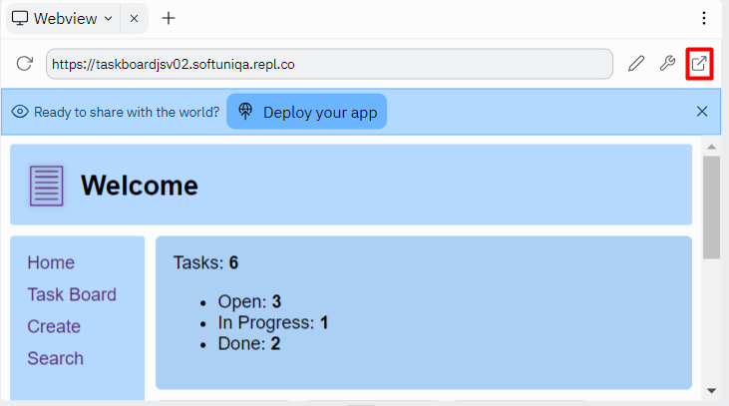

**Step 7:** This should open the app in a new tab and you are ready to go.